**Ingram School of Engineering**

**Texas State University**

**EE 3150: Microelectronics Lab**

**Lab Activity 3: Diode Rectifier**

***This lab activity was created and graciously provided by Dr. Karl Stephan***

**1. Before coming to lab on the assigned day:**

Simulate the following Fig. 1 circuit in Multisim or an equivalent circuit-simulation software package:

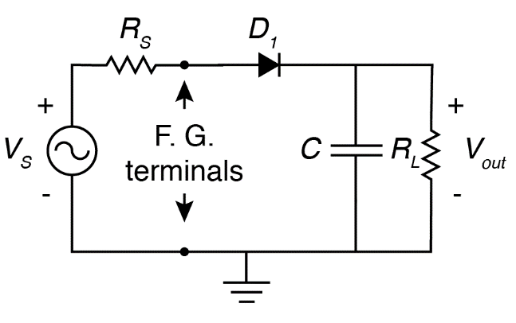

Fig. 1. Diode rectifier test circuit. *RL*  = 3.3 kW, diode is 1N4001 (a silicon rectifier diode), *C* = 220 *m*F. *RS* = 50 W is internal to the function generator (F. G.) (do not put *RS* in your circuit).

Initially assume that *VS* is an AC sine wave with a frequency *f1* = 60 Hz and peak voltage *VP* = 10 V.

Prepare a report of less than two pages which includes the following data and records:

* An explanation of what you will learn from this lab.

**how a diode rectifier converts AC voltage into DC voltage, and how adding a capacitor filter smooths the rectified waveform.**

* An explanation of what waveform you expect to see at *Vout* (average DC voltage *VDC* and peak-to-peak ripple *VRIPPLE*).

**At Vout, I expect to see a DC voltage with a small sawtooth-shaped ripple superimposed on it.**

* **At 60 Hz, the ripple is larger because the capacitor discharges longer between peaks.**
* **At 400 Hz, the ripple is very small, so the waveform looks almost flat**
* Calculations of predicted average DC voltage *VDC* and AC voltage *VRIPPLE* for both 60-Hz and 400-Hz cases.

* Using the simulation software, measurements of *VDC* and peak-to-peak ripple *VRIPPLE*. Also show a screen shot of the waveform at *Vout*.

**Vpp = 2 sqrt(3) VRms**

**60 Hz: VDC =9.215V, VRIPPLE = 0.205**

**400 Hz: VDC =9.236 V, VRIPPLE = 0.0354**

Change the source frequency to *f2* = 400 Hz and repeat calculations and measurements of *VDC* and peak-to-peak ripple *VRIPPLE* for the higher frequency. If the scope function in your simulation software has an AC-DC option, choose the AC option for measuring *VRIPPLE* to eliminate the DC offset and keep the waveform on the screen.

Show your report to the TA or instructor at the beginning of the lab, and you will receive a prelab grade for that report.

**2. In the lab on the assigned day:**

* Build the circuit shown in Fig. 1, using the Keysight 33612A function generator for *VS*. See the instructor or TA about how to set up the function generator to produce a voltage at frequency *f1* = 60 Hz.
* Using the scope, verify that the peak value of *VS* is 10 V. Then measure the average DC value of *Vout* (*VDC*) and the ripple voltage *VRIPPLE*.

**Vout = 8.106V, Vripple = 214mV**

* Change the source frequency to *f2* = 400 Hz and repeat your measurements of *Vout* (*VDC*) and the ripple voltage *VRIPPLE*.

**Vout = 8.08V, Vripple = 67mV**

* You must finish the lab during your assigned lab period. No lab makeups are allowed without an excused absence or other documented reason.
* ***Include at least 2 pictures with your lab report, one of the setup and at least one of instrument readout. In addition, selfies are encouraged!***

